**Predicting the Price of Used Toyota Corolla Cars**

A large Toyota car dealership offers purchasers of new Toyota cars the option to buy their used car as part of a trade-in. In particular, a new promotion promises to pay high prices for used Toyota Corolla cars for purchasers of a new car. The dealer then sells the used cars for a small profit. To ensure a reasonable profit, the dealer needs to be able to predict the price that the dealership will get for the used cars. For that reason, data were collected on all previous sales of used Toyota Corollas at the dealership. The data include the sales price and other information on the car, such as its age, mileage, fuel type, and engine size. A description of each of these variables is given in Table 6.1.

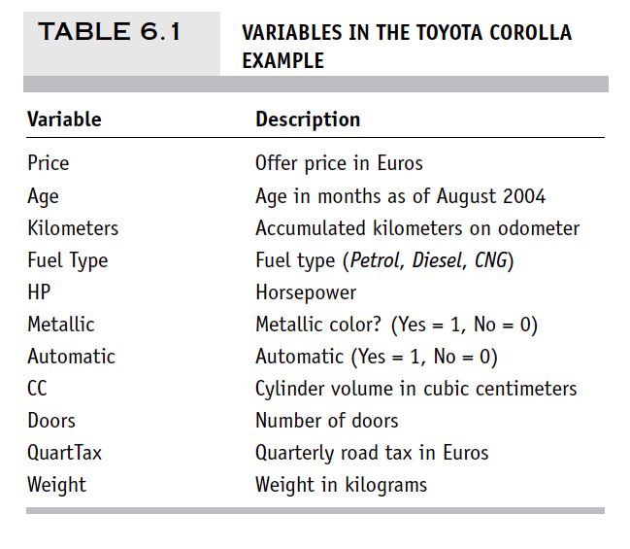

Can we predict the price of a car using the data given to us?